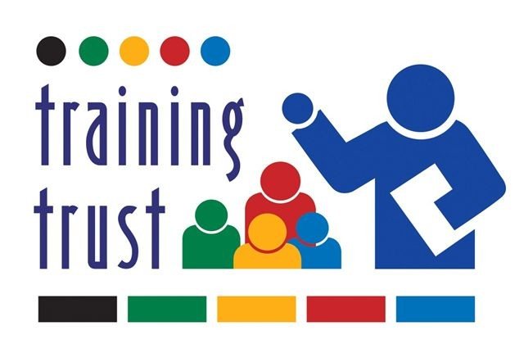
MISSION STATEMENT

Our mission is to ‘Support the success of our learners and partners’.

VISION

Our vision is that:

- We provide a supportive learning environment that enables learners to succeed in their chosen career
- Learners are given the opportunity to develop their skills and knowledge in their preferred pathway, enabling them to lead fulfilling lives
- Learners achieve their chosen aims within a safe and enjoyable learning environment
- We provide learners with the skills, knowledge and behaviours to exceed their expectations and progress further after their time with us

OUR CULTURE AND VALUES

- We aim to offer high-quality training in partnership with employers and other providers of education and training.
Our staff members are committed to;
  - Ensuring every learner achieves their chosen objectives
  - Providing a safe and enjoyable learning environment for every learner
  - Providing support to all learners to enable them to overcome barriers to learning
  - Working closely with employers to support them in providing a high-quality learning environment and up-skilling their workforce
  - Supporting individuals in leading lives that enable them to make a positive contribution to their community
  - Improve the employability skills and personal development of all learners who participate in our training programmes
- We will investigate and source cost-effective, high-quality training and education in order to support social inclusion and promote social mobility

Mark Durham
Chief Executive
August 2025

